SIMATS ENGINEERING
MODEL PRACTICAL EXAMINATION – Aug._2026
COURSE NAME: Artificial Intelligence COURSE CODE: CSA1709
Register Number | 192524358
Name | Shaik. Abdul Razak

SET:11

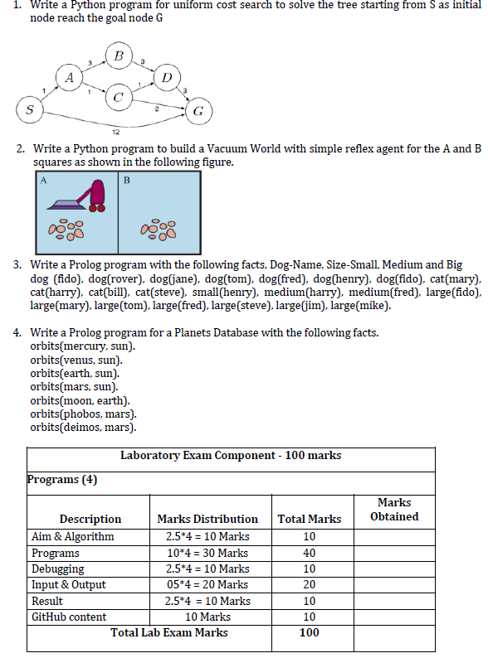

PROGRAM 1

Aim: To write a python program for uniform cost search to solve the tree starting from S as initial node
Reach the goal node G

Algorithm
- Represent the graph using an adjacency list with edge costs.
- Insert the initial node S into a priority queue with cost 0.
- Remove the node having the lowest path cost.
- If the removed node is G, display the path and total cost.
- Otherwise, expand its unvisited neighbouring nodes.
- Add each neighbour to the priority queue with its updated cumulative cost.
- Continue until the goal node is reached.

Python Program:

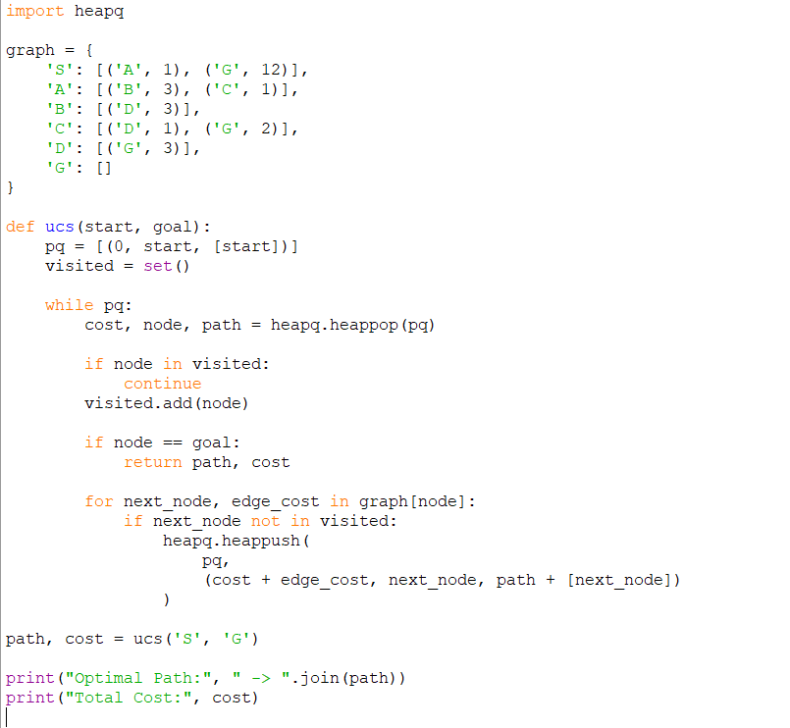

Input
Initial Node: S
Goal Node: G

Output

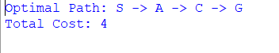
Debugging
- Used heapq to maintain the lowest-cost node.
- Checked that all graph nodes and edge costs were correctly entered.
- Used a visited set to avoid repeated expansion.
- Verified that the cumulative path cost is calculated correctly.
Result
Thus, the Uniform Cost Search program was successfully executed and the minimum-cost path from S to G was found as:
S → A → C → G with total cost 4.

PROGRAM 2

Aim:
To write a Python program to implement a Simple Reflex Agent for a two-room Vacuum World containing rooms A and B.

Algorithm
- Represent rooms A and B with their current status: Clean or Dirty.
- Place the vacuum agent in either room.
- Check the condition of the current room.
- If the current room is dirty, perform the Suck action.
- If the current room is clean, move to the other room.
- Repeat until both rooms become clean.
- Display the actions performed by the agent.

Python Program

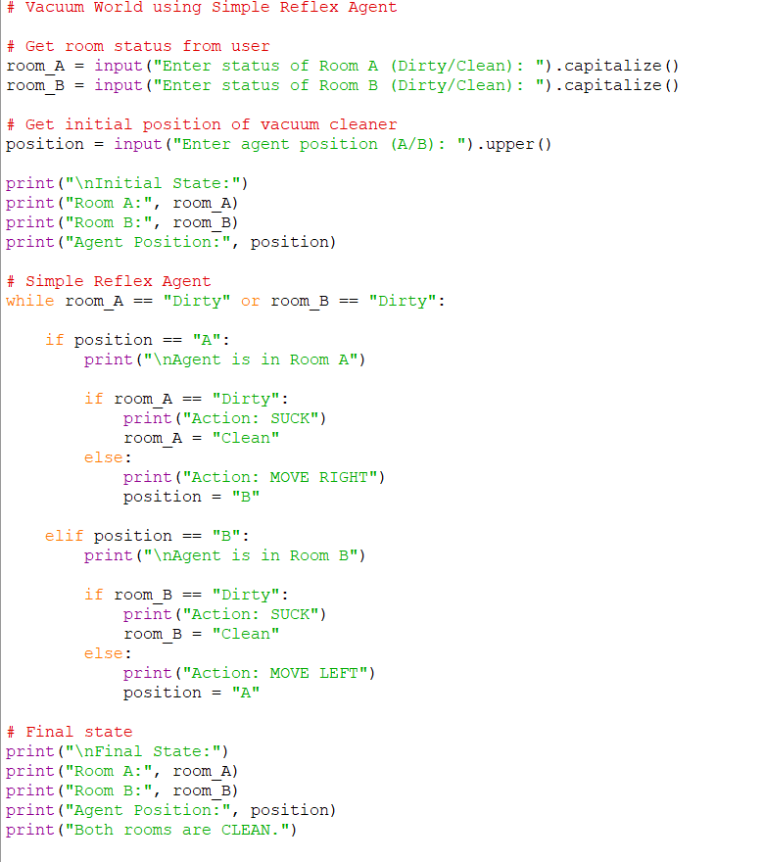
Input:

Enter status of Room A (Dirty/Clean): Dirty
Enter status of Room B (Dirty/Clean):
Dirty Enter agent position (A/B): A

Output:

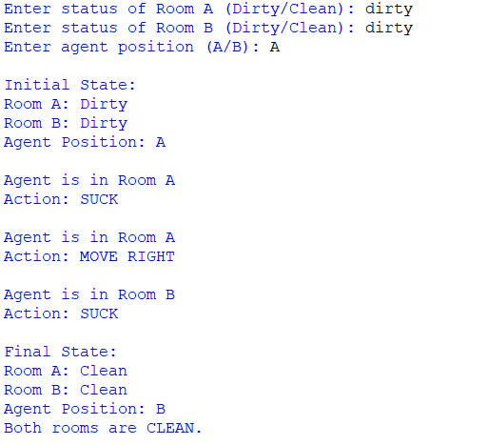

Debugging
- Used capitalize() to handle Dirty and Clean input consistently.
- Used upper() for room position.
- Checked that the agent moves only between A and B.
- Verified that the loop terminates when both rooms are clean.
Result
Thus, the Simple Reflex Agent was successfully implemented. The agent cleans a dirty room using Suck and moves to the other room when the current room is clean.

PROGRAM 3:

Aim
To write a Prolog program using facts and queries to represent dogs, cats, and their sizes such as Small, Medium and Large.

Algorithm
- Define facts representing different dogs.
- Define facts representing different cats.
- Define size facts such as small, medium and large.
- Load the program into a Prolog interpreter.
- Execute queries to retrieve animals and their sizes.
- Display the results obtained from the database.

Prolog Program

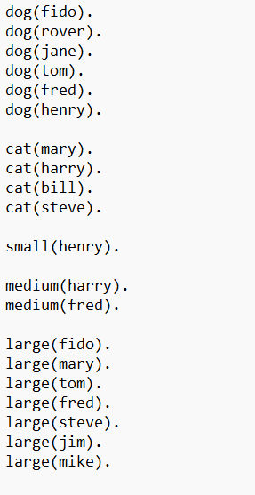
Sample input:
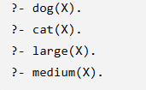

Output:

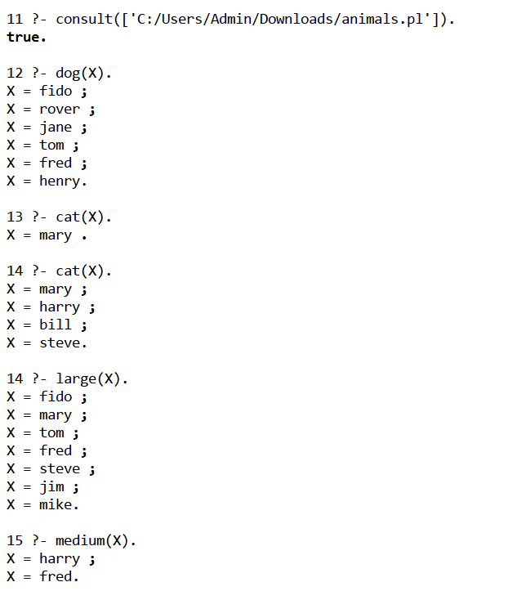

Debugging
- Every Prolog fact ends with a period ..
- Predicate names and constants are written in lowercase.
- Variables are written using uppercase letters.
- Checked spelling of predicate names such as dog, cat, small, medium and large.

Result
Thus, the Prolog animal database was successfully created and queries were executed to retrieve dogs, cats and their respective sizes.

PROGRAM 4:

Aim
To write a Prolog program for a Planets Database using facts representing the orbital relationship between planets, moons and the Sun.

Algorithm
- Define the orbits/2 predicate.
- Store each celestial object's orbital relationship as a fact.
- Load the program into a Prolog interpreter.
- Query the database using variables.
- Prolog matches the query with the available facts.
- Display all matching orbital relationships.

Prolog Program
% Planets Database

orbits(mercury, sun).
orbits(venus, sun).
orbits(earth, sun).
orbits(mars, sun).
orbits(moon, earth).
orbits(phobos, mars).
orbits(deimos, mars).

Sample Input:
?- orbits(X, sun).

Sample Output:
X = mercury ;
X = venus ;
X = earth ;
X = mars ;
false.

Sample Input:
?- orbits(X, mars).

Sample Output:
X = phobos ;
X = deimos ;
false.

OUTPUT:

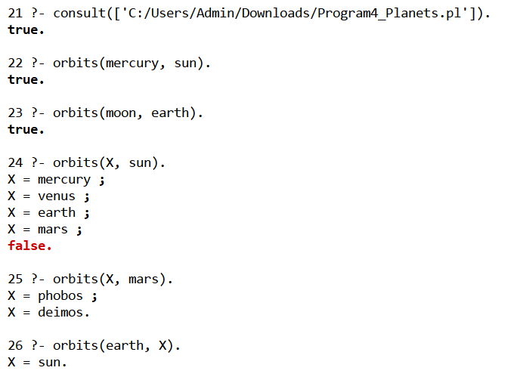
Debugging

- Checked that every fact ends with a period.
- Used lowercase names for constants.
- Used uppercase X as the query variable.
- Verified the order of arguments in orbits(Object, Body).
- Checked that sun, earth and mars are consistently written.

Result
Thus, the Planets Database was successfully implemented in Prolog and orbital relationships were retrieved using Prolog queries.

